

A PROJECT REPORT ON

**“PERSONAL FINANCE TRACKER”**

**Submitted By:-**

Mayur Sopan Jagzap

**PRN:- 2124UCEM1020**

**Subject :-**

Programming And problem solving

Using c++

**UNDER THE GUIDANCE OF :-**

Miss. Ishwari tirse mam

**Department of Computer Science and Engineering**

**Sanjivani Rural Education Society**

**SANJIVANI UNIVERSITY**

|  |  |
| --- | --- |
|  | **Content** |
| **1** | **Introduction** |
| **2** | **Code** |
| **3** | **Output** |
| **4** | **Conclusion** |
| **5** | **Features of this system** |

**INDEX**

**Introduction**

**A Personal Finance Tracker is a tool designed to help users manage their finances by tracking income, expenses, and savings goals. Managing finances can be challenging, especially with the variety of expenses and income sources people encounter. A finance tracker aims to simplify this by offering a straightforward way to record financial transactions, monitor spending habits, and achieve savings goals.**

**Code**

**#include <iostream>**

**#include <vector>**

**#include <string>**

**#include <iomanip>**

**using namespace std;**

**// Struct to represent a transaction**

**struct Transaction {**

**string type;**

**string description;**

**double amount;**

**};**

**// Class for Personal Finance Tracker**

**class FinanceTracker {**

**private:**

**vector<Transaction> transactions;**

**double balance;**

**public:**

**FinanceTracker() : balance(0.0) {}**

**// Function to add income**

**void addIncome(double amount, const string &description) {**

**Transaction transaction = {"Income", description, amount};**

**transactions.push_back(transaction);**

**balance += amount;**

**cout << "Income added: " << amount << "\n";**

**}**

**// Function to add expense**

**void addExpense(double amount, const string &description) {**

**Transaction transaction = {"Expense", description, amount};**

**transactions.push_back(transaction);**

**balance -= amount;**

**cout << "Expense added: " << amount << "\n";**

**}**

**// Function to display all transactions**

**void viewTransactions() const {**

**cout << "\n--- All Transactions ---\n";**

**cout << left << setw(10) << "Type" << setw(20) << "Description" << setw(10) << "Amount" << "\n";**

**for (const auto &transaction : transactions) {**

**cout << left << setw(10) << transaction.type**

**<< setw(20) << transaction.description**

**<< fixed << setprecision(2) << setw(10) << transaction.amount << "\n";**

**}**

**}**

**// Function to display the current balance**

**void showBalance() const {**

**cout << "\nCurrent Balance: $" << fixed << setprecision(2) << balance << "\n";**

**}**

**};**

**// Main function**

**int main() {**

**FinanceTracker tracker;**

**int choice;**

**double amount;**

**string description;**

**do {**

**cout << "\n--- Personal Finance Tracker ---\n";**

**cout << "1. Add Income\n";**

**cout << "2. Add Expense\n";**

**cout << "3. View Transactions\n";**

**cout << "4. Show Balance\n";**

**cout << "5. Exit\n";**

**cout << "Enter your choice: ";**

**cin >> choice;**

**switch (choice) {**

**case 1:**

**cout << "Enter income amount: ";**

**cin >> amount;**

**cout << "Enter description: ";**

**cin.ignore();**

**getline(cin, description);**

**tracker.addIncome(amount, description);**

**break;**

**case 2:**

**cout << "Enter expense amount: ";**

**cin >> amount;**

**cout << "Enter description: ";**

**cin.ignore();**

**getline(cin, description);**

**tracker.addExpense(amount, description);**

**break;**

**case 3:**

**tracker.viewTransactions();**

**break;**

**case 4:**

**tracker.showBalance();**

**break;**

**case 5:**

**cout << "Exiting the tracker.\n";**

**break;**

**default:**

**cout << "Invalid choice. Please try again.\n";**

**break;**

**}**

**} while (choice != 5);**

**return 0;**

**}**

**output**

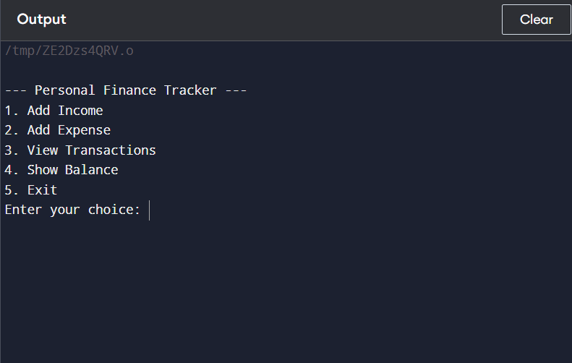

**Conclusion**

**A Personal Finance Tracker is a straightforward tool that allows users to manage their income and expenses effectively through a command-line interface. By adding income and expenses, users can easily keep track of their finances, view past transactions, and monitor their current balance.**

**Feature of this system**

**Add Income**

* **Users can add income transactions with a specific amount and description (e.g., "salary" or "freelance payment").**
* **Each income entry is added to the overall balance.**

**Add Expense**

* **Users can add expenses, specifying an amount and description (e.g., "groceries," "rent," or "entertainment").**
* **Each expense entry is deducted from the overall balance, helping users track where their money is going.**

**View All Transactions**

* **Displays a list of all transactions, showing the type (income or expense), description, and amount.**
* **Helps users review their spending and income history.**

**Current Balance Display**

* **Shows the current balance based on all income and expenses entered.**